[Internship Report.docx](Internship%20Report.docx)



ADAMA SCIENCE AND TECHNOLOGY UNIVERSITY

SCHOOL OF ELECTRICAL AND COMPUTING ENGINEERING

DEPARTEMENT OF COMPUTER SCIENCE AND ENGINEERING

NAME: DARARA TESFAYE MAMO

ID. NO: UGR/22840/13

UNIVERSITY ADVISOR: MR.______________________

HOSTING COMPANY: BACKOS TECHNOLOGY PLC.

COMPANY SUPERVISOR: MR.LEUL GETANEH

DURATION: 60 DAYS

SUBMISSION DATE: __/OCT/2023

# DECLARATION

I am Darara Tesfaye 4th year computer science and Engineering student. Here by I declare that this final internship report has been submitted to my University. The objective of this report is to explain what I did and learned especially integration of the theoretical knowledge what I have been learnt with practical skills, developing interpersonal communication skills, team working skills, leadership skills, work ethics and entrepreneurship skills during internship stay in Backos Technology PLC. In this company I was spent two months in the internship program.

# EXECUTIVE SUMMARY

The internship program is intended to teach students on different parts of computer science and engineering tasks. And also Internship program is the best thing for students to change their theoretical knowledge that they get from class from different course into practical knowledge and to face the real world situation before taking serious commitment. It has been a great experience that I learned a lot from it. I developed my theoretical skills and practical skills.It also helps students to develop different skill like practical, interpersonal communication, entrepreneur, and leadership skills.

# ACKNOWLEDGEMENT

Any accomplishment requires the blessing of the God. So first thanks goes to God. I also want thank my advisor Mr. ___________________ from my university (ASTU). And also I want thank my supervisor Mr. Leul Getaneh from hosting Backos Technology PLC. Company and all members of that company for their continuous comments in every steps of the practice work that they forward throughout the internship period.

I would like to express my heartfelt gratitude to Backos Technology PLC for providing me with this incredible opportunity. I extend my appreciation to Backos members who have generously shared their knowledge and expertise, guiding me through challenging project and gave feedback on my project or practice work.

Finally, a big thank to my family for their encouragement, patience and support throughout my internship period.

# LIST OF ACRONYMS

WWW ………………………………………….World wide web

PLC ………………………………………….public limited company

Declaration

Executive Summary

Acknowledgement

List of Acronyms

Table of Contents

Declaration 2

Executive summary 2

Acknowledgement 2

List of acronyms 3

List of figure 5

Chapter one 6

1.1 Overview 6

1.1.1 Objective of internship 6

1.1.2 Scope of work 7

1.1.3 Output expected 7

1.2 Background of organization 8

1.2.1 Description of the organization 8

1.2.2 Mission of the organization 8

1.2.3 Products/ services of the organization 8

Chapter two 9

2.1 Major duties given to me to perform 9

2.2 How did i become oriented with the responsibilities i were assigned 9

2.3 How did the supervisor help me to succeed in the assignment i were given 9

2.3.1 From site 9

2.3.2 From university 10

2.4 What qualities did i develop which allowed me to succeed in daily duties? 10

Chapter three 10

3.1 Duties and responsibilities i had during internship 10

3.1.1 Internship plan 10

3.1.2 Development of portfolio 11

3.1.3 Project execution 14

3.2 Other responsibilities and duties i had during internship 25

3.3 Technical knowledge and skills from my course beneficial for my assignment 25

3.4 Relevant research projects i had identify in my activities in the organization 26

Chapter four 26

4.1 How did internship fit my career goals 26

4.2 Did my career goals changed as a result of the internship? 26

4.3 My feelings about the importance of this internship 26

4.4 What challenges i faced during the internship? 26

4.5 Strength and areas of the improvement 26

4.5.1 Strengths 26

4.5.2 Areas of improvement 27

Chapter five 27

5.1 Comment with my personal opinion of the company and the internship 27

5.2 Recommendations for improving the internship 27

5.5.1 For the university 27

5.5.2 For the hosting organization 27

5.3 Should you consider the company for the future student placement? 28

Chapter six 28

Reference 28

# LIST OF FIGURE

# CHAPTER ONE

INTRODUCTION

## 1.1 Overview

A summer internship program is a structured period of work experience offered by university or organization to students during summer months. It provides an opportunity for students to gain practical skills, industry exposure, and apply academic knowledge in real world work setting.

### 1.1.1 Objective of internship

The main objective in this internship is gain practical experience and develop skills in web development, contributing to the company projects while learning and growing in professional skill

* Develop professional practice and adherence to codes of professional ethics, including ethical decision making.
* Provide opportunities to acquire student qualifications if it is the qualification requirement to acquire work place component for completion;
* Sharpen aspects of professionalism, including honesty/integrity, reliability/responsibility, respect for others, compassion/empathy, advocacy
* Develop new knowledge and skills
* Work independently and with others, both within and outside the organization/company, applying professional knowledge and skills,
* Observe the functioning of the company, including the administration and activities,
* Build upon previous knowledge and experiences by working within and critically appraising a professional setting,
* Resolve the general shortage of qualified and skilled people in the work force by encouraging graduates to equip themselves with the necessary practical experience
* Gain career knowledge and evaluate career options and goals
* Demonstrate professional skills in the workplace;
* Built and maintain positive professional relationships;
* Demonstrate awareness of community and/or organizational issues;
* Identify, clarify and/or confirm professional direction as it relates to my academic studies and future career path
* Apply technology and analytical skills to a specific work setting
* Link academic theory to practice in your discipline;
* Apply your knowledge, skills and experience to a work environment;
* Acquire new learning through challenging and meaningful activities;
* Reflect on the content and process of the learning experience;
* Apply concepts and skills gained from academic experience to a professional work setting,

### 1.1.2 Scope of Work

* Internship plan which outlining learning goals, specific project to be achieved over the internship period.
* Implement front-end and back end functionalities functionalities using HTML, JavaScript, CSS, PHP and some frameworks.
* Collaborate with the team to design, develop, maintain websites.
* Create responsive web design like portfolio.
* Perform website testing, bug fixing, and optimization
* Participation in code reviews and follow best practices for coding standards.
* Maintain regular communication channels to discuss progress, updates and any challenges faced during internship.
* Present completed projects to the team, highlighting key features, functionalities and technical challenges overcome.

### 1.1.3 Output expected

* A successful internship can give students valuable information in making decisions about the direction of future studies or employment.
* Student should gain practical experience in website development.
* Student should acquire knowledge and skills in backend and front end development.
* Student should gain an understanding of web standards, accessibility guidelines, and industry best practices.
* Student should develop problem solving abilities specific to web development challenges.
* Student should provide well-documented code, including comments and proper styling conventions.
* An internship is an opportunity not only uses and develops industry-related knowledge and skills, but also to enhance some of the skills that are transferable to any professional work setting. The internship can also play significant role in creating and strengthening University and Industry Linkage and communication.

## 1.2 Background of Organization

Backos Technology PLC was established for the software solutions. It is located in Oromia region East Shewa zone, Adama City Ganda Gooroo kebele.

### 1.2.1 Description of the Organization

Backos Technology PLC is a partner of his customer in IT Consultation, Business Automa, Software innovation and technological advancement. Backos Technology company contains young and energetic staff to provide a very fast and reliable services. Their staff or team are professional IT.

### 1.2.2 Mission of the Organization

Backos believes that they can bring the greatness that our country had in past by solving social, economic and political problems using modern technologies.

### 1.2.3 Products/ Services of the Organization

* Product of the backos technology.
* Development of powerful and user friendly technology
* Software development
* Product Design
* Data analytics
* Cyber Security

Services of the Backos technology

* Web development
* Develop ERP, CRM, inventory system
* Network installation
* Develop stable and user friendly mobile application for both iOS and Android.
* IT Consultancy
* Design UI/UX
* CCTV System Installation

# CHAPTER TWO

MANAGEMENT, TRAINING, AND EMPLOYEE INFORMATION

## 2.1 Major duties given to me to perform

* Internship plan which we should have to do during internship period. This plan contains my role and responsibility, required resources for the internship and so on. And another is doing practice by following that internship plan.
* Develop static personal Portfolio website. In developing this personal portfolio we use HTML, CSS, JavaScript efficiently and also we should have to write clean code with descriptive comments and submit it on time.
* Allocate time for self-learning, exploring new websites and submit it to them. By corresponding to plan and duties given to me to perform I develop online shopping projects.

## 2.2 How did I become oriented with the responsibilities I were assigned

On the whole of my internship period I arrived at the workplace and also we communicate with the hosting company via online like Telegram, Google meeting. And through those method they inform and assign a responsibility to us. I also done all the duties given to me throughout the working period. I showed a good interest for getting new knowledge and information (I was curious).

## 2.3 How did the supervisor help me to succeed in the assignment I were given

### 2.3.1 From Site

* By assisting me in identifying learning opportunities and setting goals and objectives for the internship period.
* By Providing orientation materials and experiences that familiarize me with the organization’s mission, objectives, and client populations.
* By Provide time and honest feedback for each of my practice and works like on my internship plan, Portfolio.

### 2.3.2 From University

* By orienting me to the purpose and requirements of the internship program.
* By professionally supervise, and giving ongoing direction, oversight, and feedback to for me.
* By collaborate with me in developing a satisfactory plan for the internship.

## 2.4 What qualities did I develop which allowed me to succeed in daily duties?

I developed the skills to work with the workers of the organization. I also learned how to work with the knowledge I get at my university with the practical applications. I developed Practical skills are developed by course design, coursework assessment, feedback, tutorials.

This internship helps me to start finding and developing leader ship qualities like management skills the ability to manage time and people (both yourself and others) successfully. And also I have gained valuable lesson that transparency and carefulness are those two very important work ethics one needs to abide and live.

# CHAPTER THREE

SPECIFIC JOB INFORMATION

## 3.1 Duties and responsibilities I had during internship

I had some of the duties and responsibilities during my summary internship program. Those duties and responsibility are as follows:-

### 3.1.1 Internship plan

At the beginning of my internship program I made a plan which contains task and ideas which I should have to perform which assigned to me from my supervisor. The plan contains objective of the internship, learning goal from the internship, my role and responsibility during internship period, why I choosing that company for it, and also what task I should have to perform at each week.

### 3.1.2 Development of Portfolio

Another responsibility assigned to me from my supervisor is developing portfolio website. This duties guidelines are it should be a single-page static website using HTML, CSS, JavaScript effectively and The code should be clean with descriptive comments. And I have done my portfolio by using the above guidelines. A photo of my portfolio I have done is as follows:-



Figure 1. Header Section of my portfolio

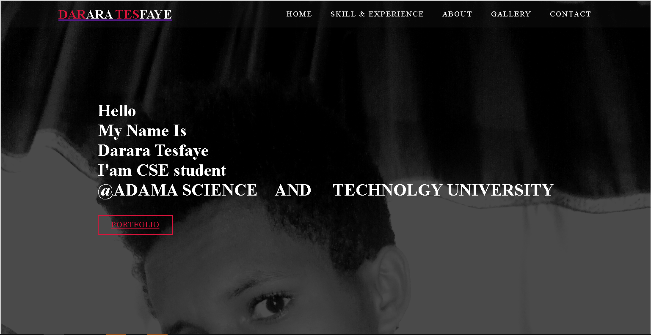

Figure 2. Home Section of my Portfolio

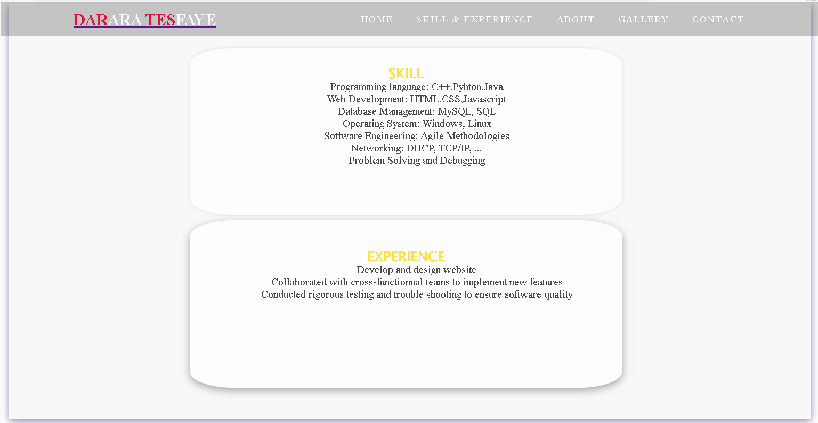

Figure 3. Skill and Experience section of my portfolio

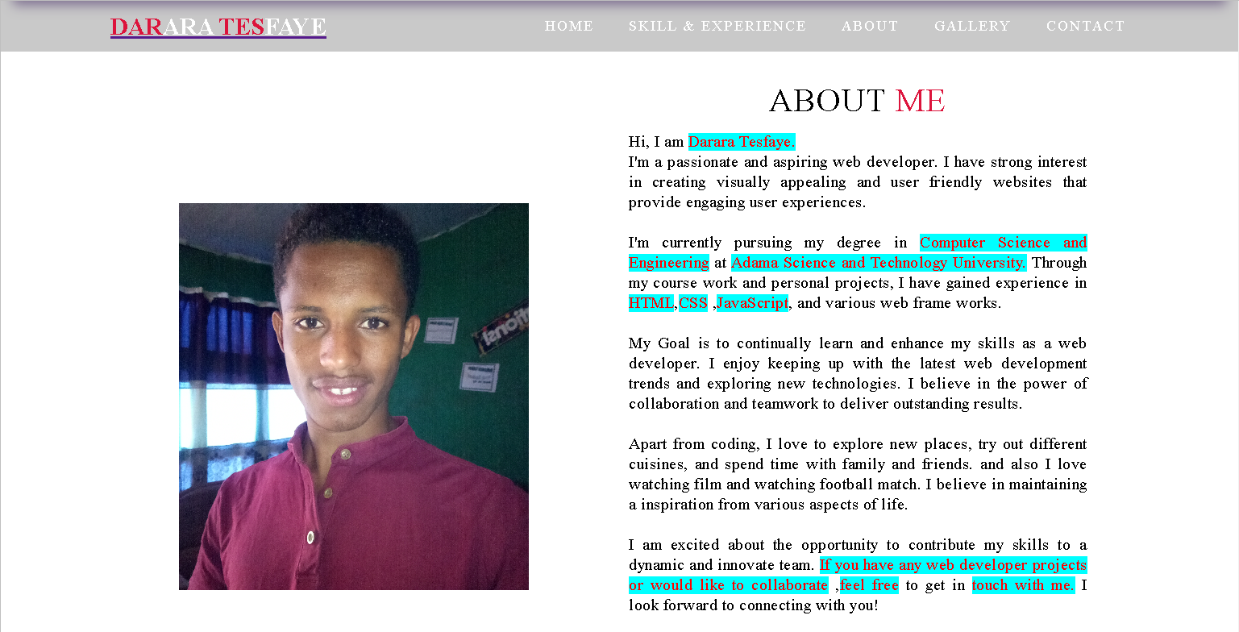

Figure 4. About me section of my Portfolio

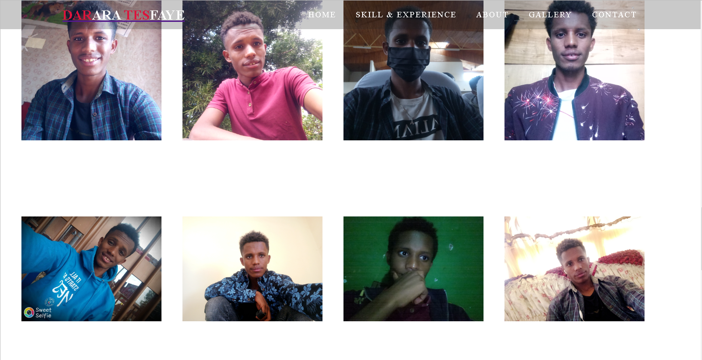

Figure 5. Gallery section of my portfolio

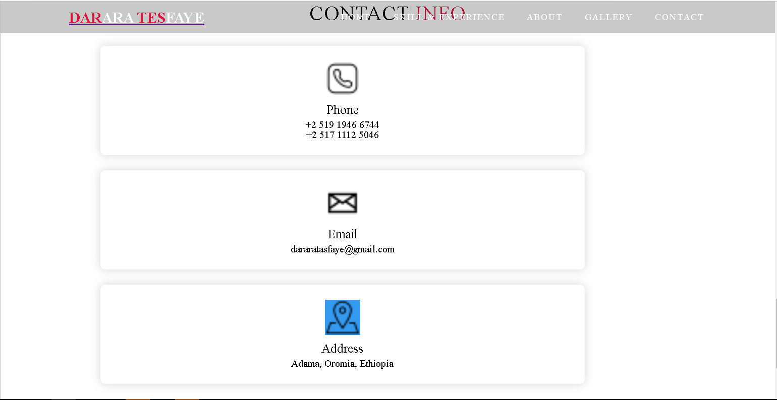

Figure 6. Contact section of my portfolio



Figure 7. Header Section of my portfolio

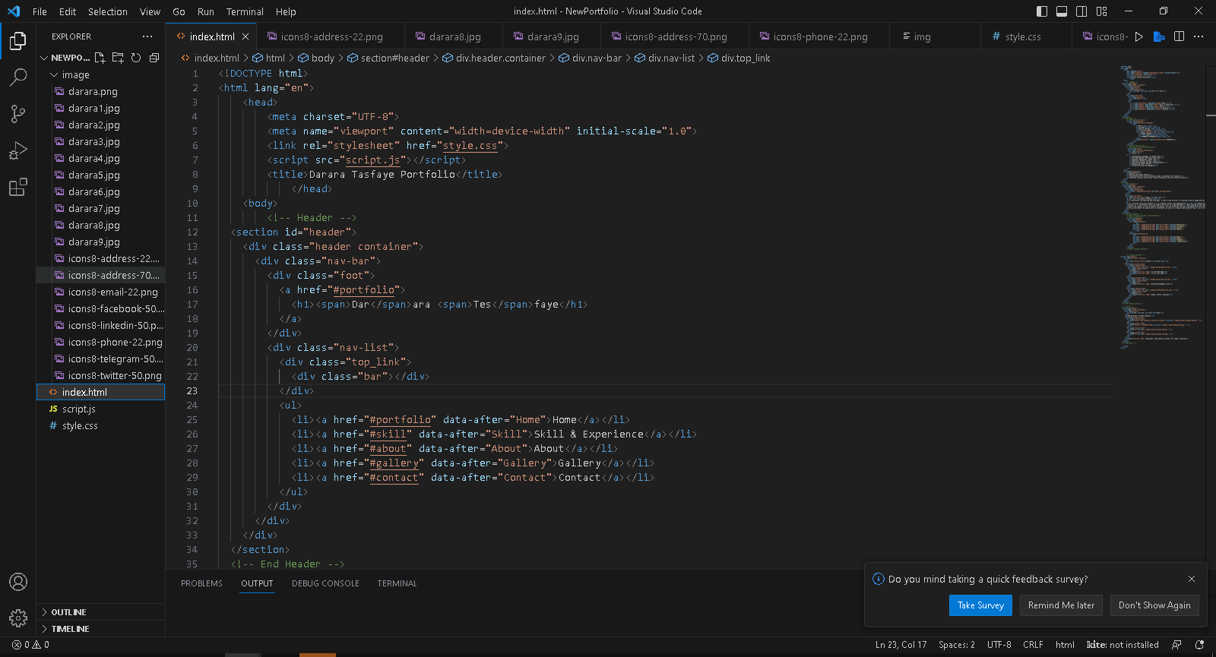

Figure 8. Program folder of my portfolio on Visual Studio

I have submitted it to my supervisor Mr. Leul Getaneh.

### 3.1.3 Project execution

Another responsibility is training and practicing to create new website. By following that I have done some projects for practicing create new website. Title of this project is called ONLINE SHOPPING.

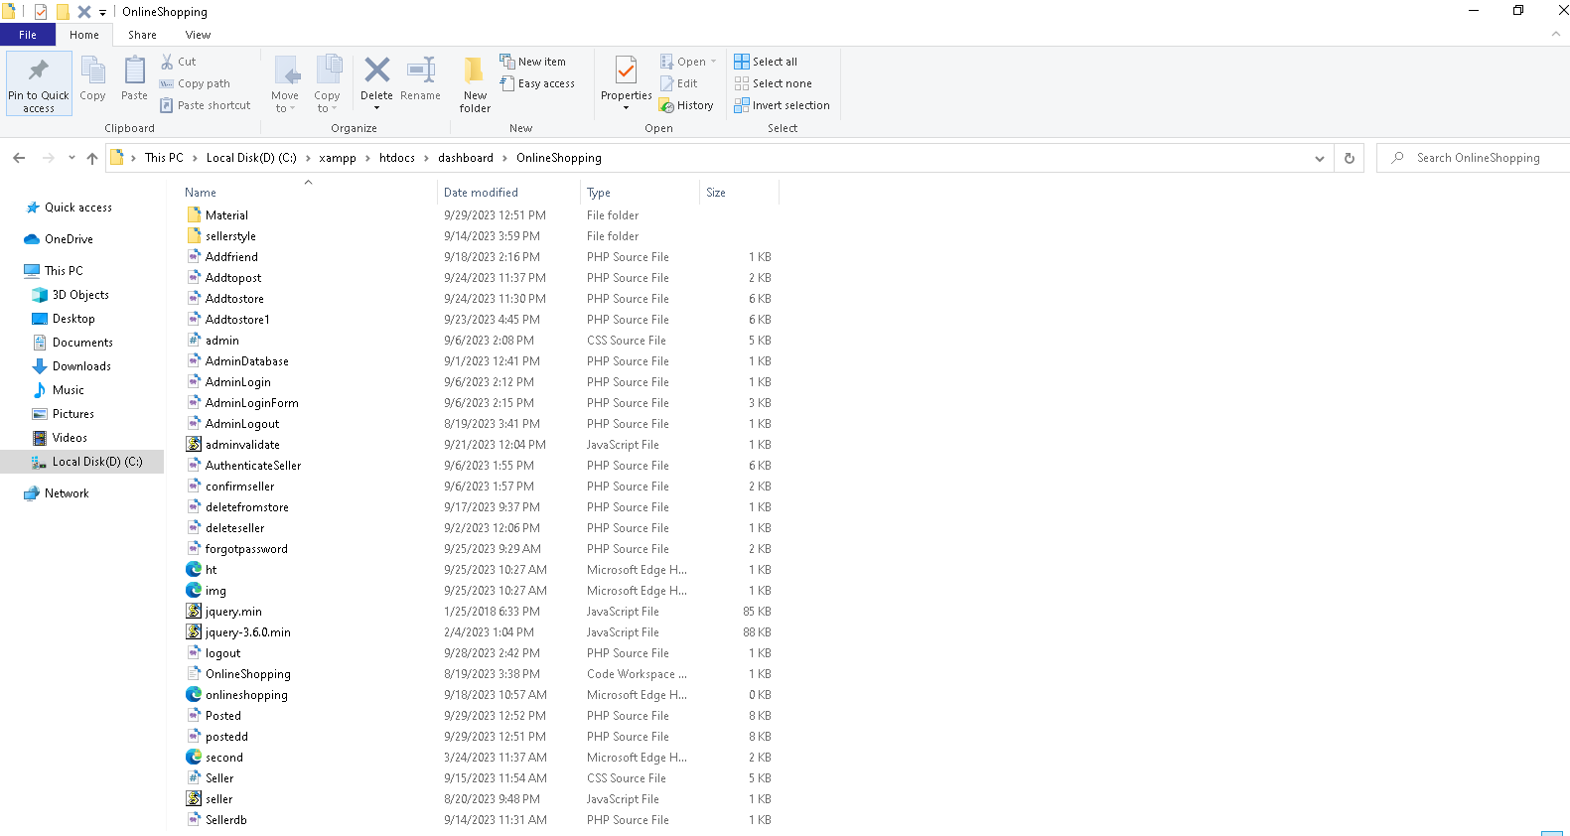 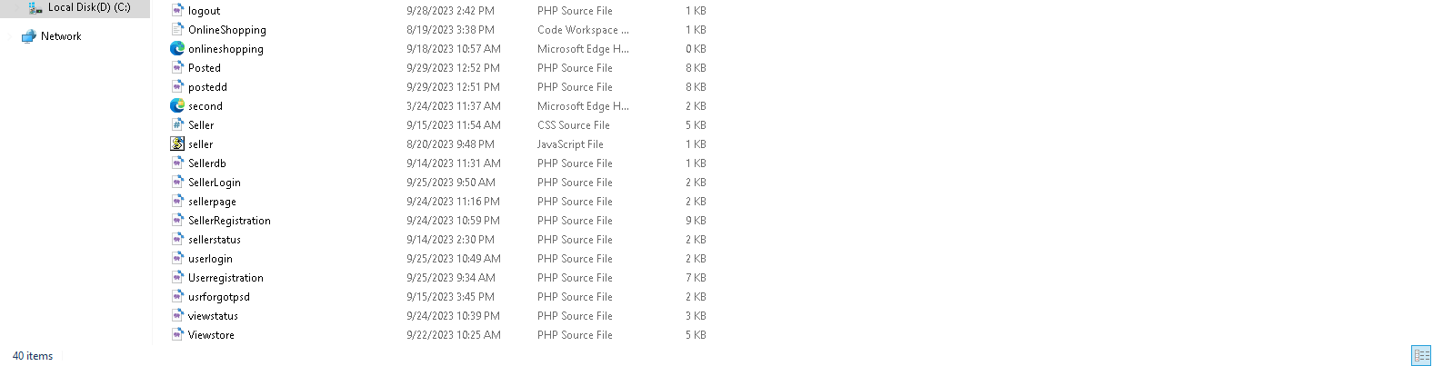

Figure 9. Online Shopping Folder

The project contains three users or Stakeholder such as admin, seller, customer (users). For those stakeholders there is web page which help them to do their activities.

#### 3.1.3.1 Admin

For that project there is only one admin with user name: **admin** and Password :**1Q2W3E4R** which is assigned by JavaScript program. First I have done the admin login form.

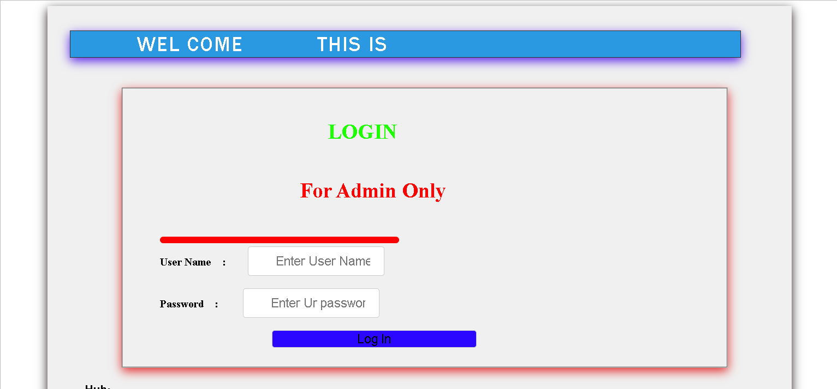

Figure 10. Admin Login Form



Figure 11. Error Message in Admin Login Form

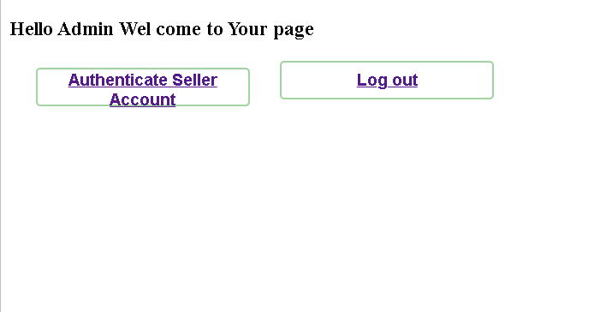

Figure 12. Admin Page

#### 3.1.3.2 Seller

First Seller should have to register and I have done first seller register form by multi step form.

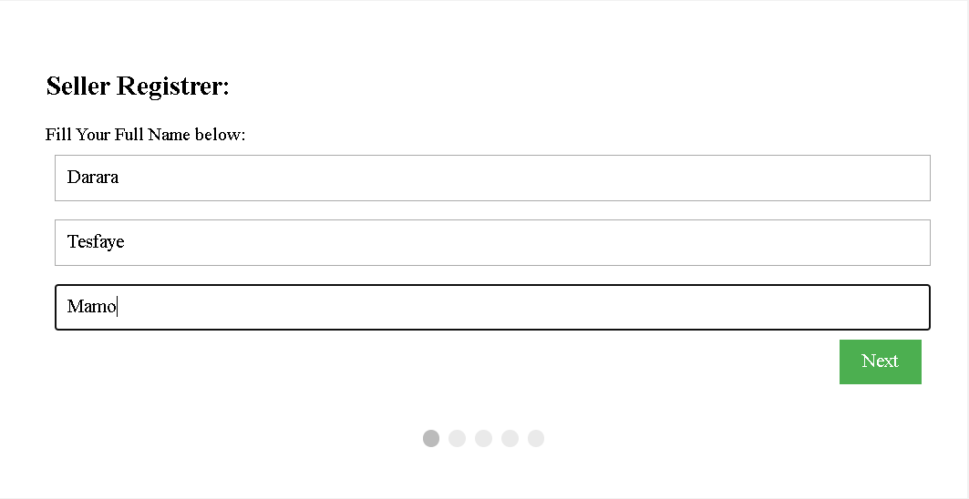 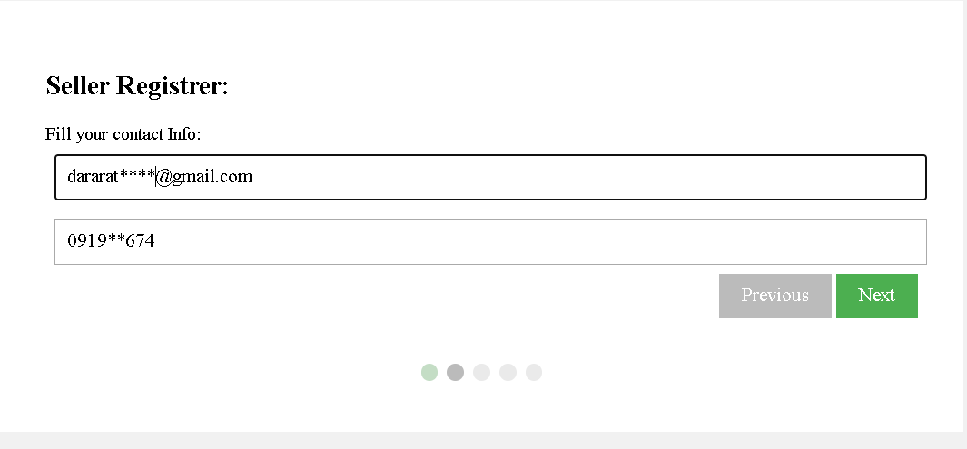 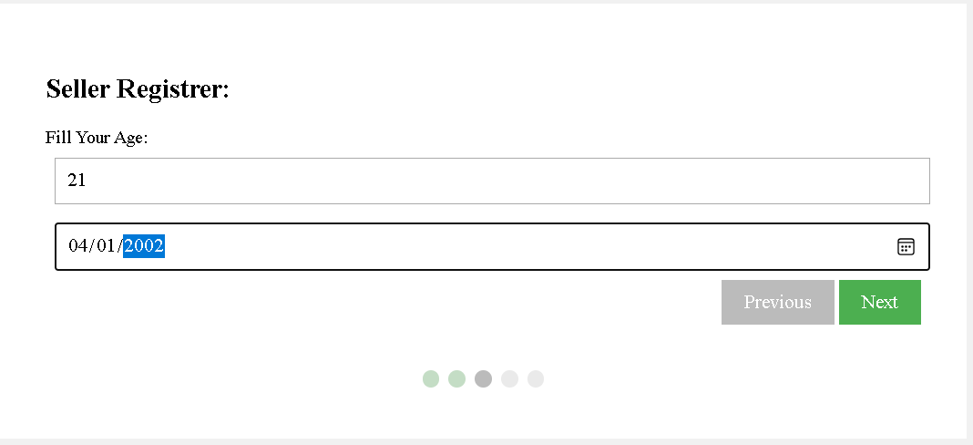 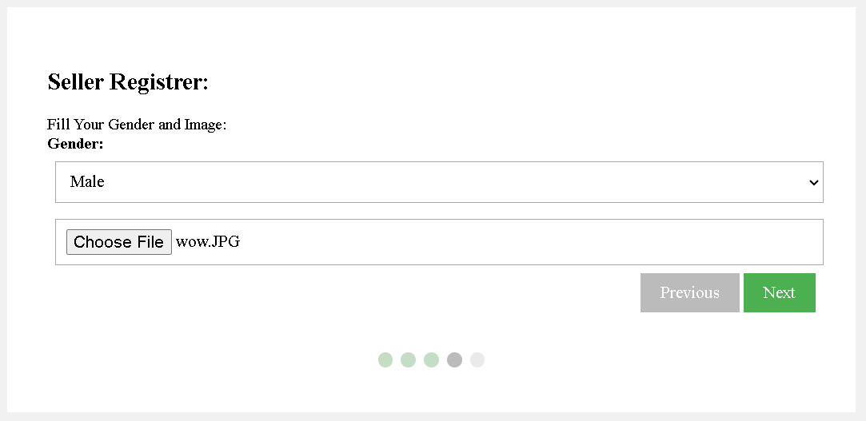 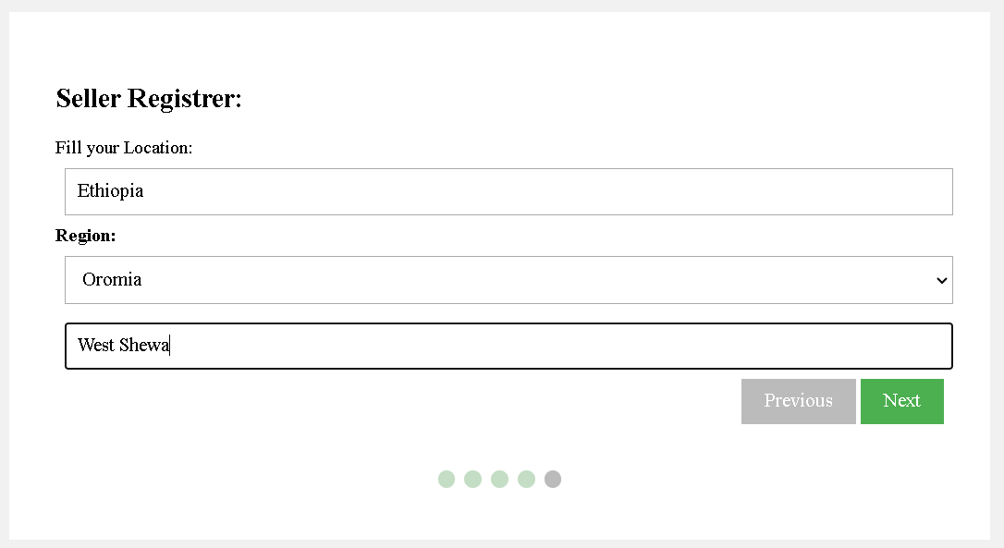 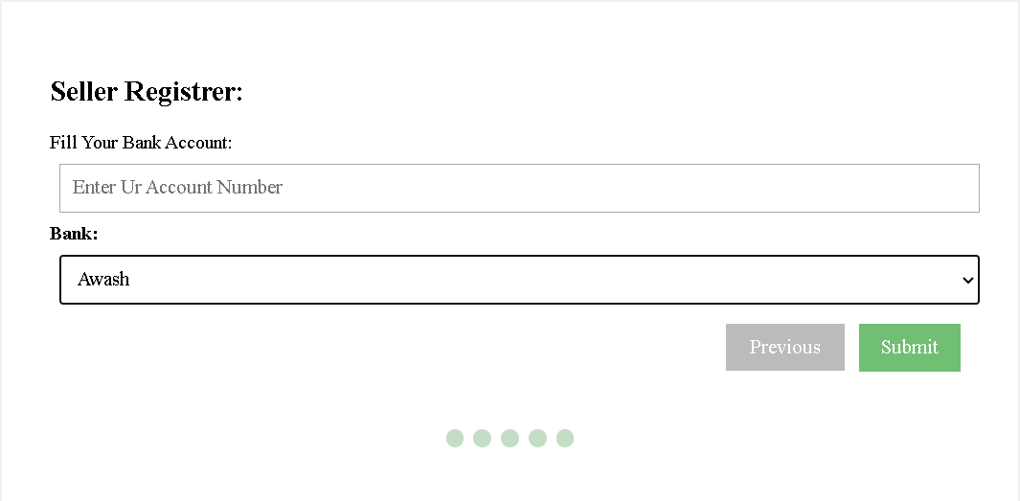

Figure 13. All step of seller registration form

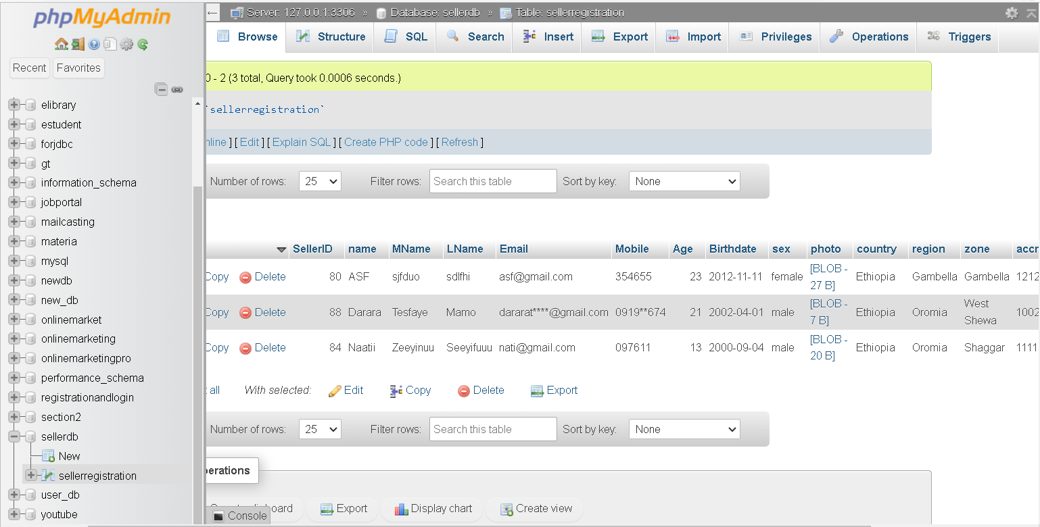

Figure 14. Registered seller in a database.

After register seller view their status by using below. If admin not confirm the seller it display error message if admin until doesnot confirm or delete it display pending fo authenticaton message.

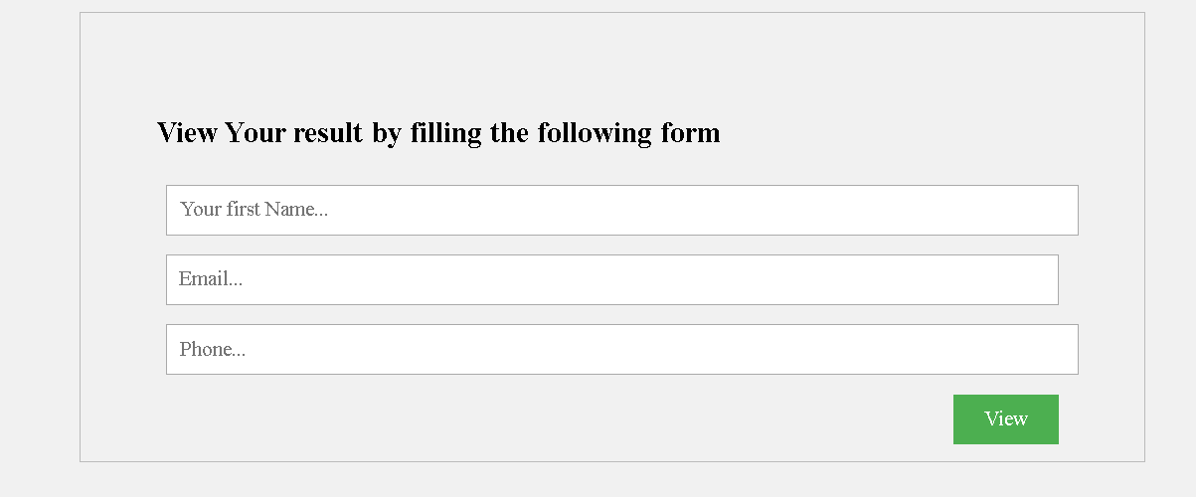

Figure 15. Seller View status page

After seller perform any activities after register admin should authenticate the seller. If admin want to confirm click on the confirm button and if he want to delete he click delete button on the corresponding rows.



Figure 16. Authenticate Seller page.

After admin confirm the user username is automatically assigned for the seller and by using that user name seller create password.

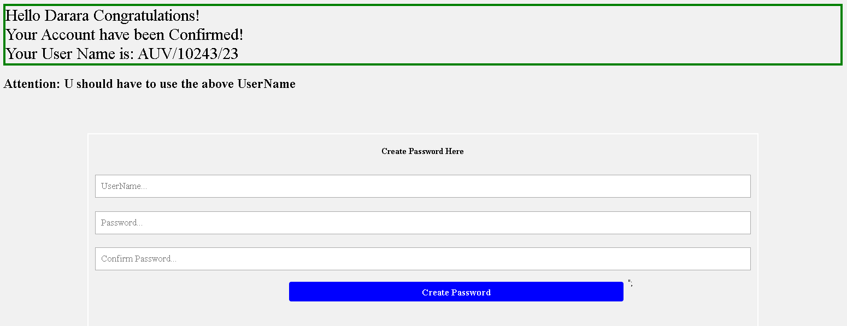

Figure 20. Seller Create Password page

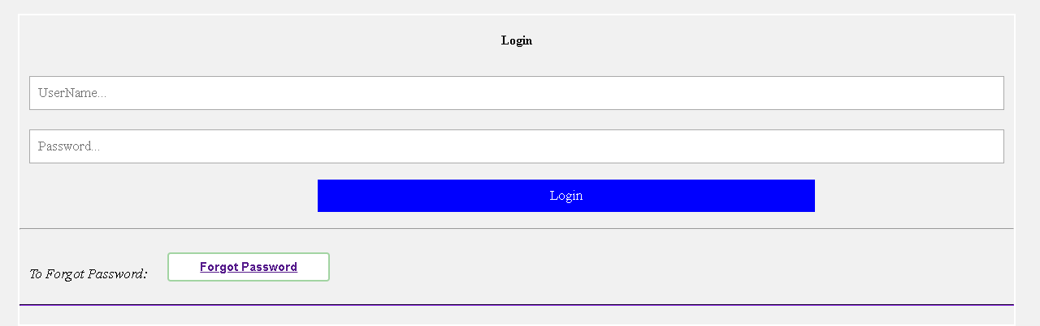

Figure 21. Seller Login Form page

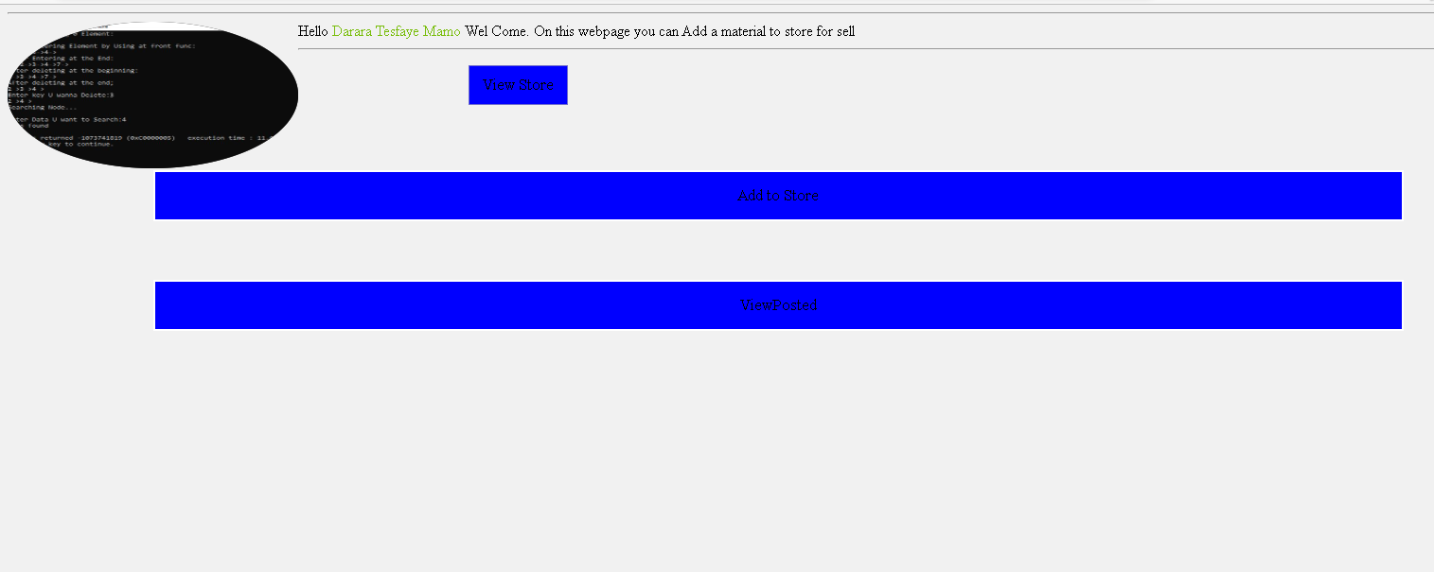

Figure 22. Seller Page

Seller can add material to the store by click on the Add to store button. To add to store there is form. And also the can view material from store. From view store there is post button and delete button. If seller click on the POST button that material is posted and if it clicks on the delete button that material is deleted from the material table.

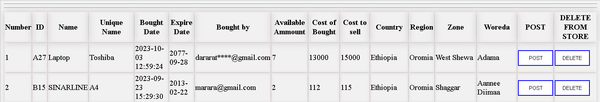

Figure 23. View Store page

Seller also can view posted material from posted page by clicking view posted page.

#### 3.1.3.3 Customer (User)

First customer register before using online shopping platform. So first I have done user customer register page from by multi step form.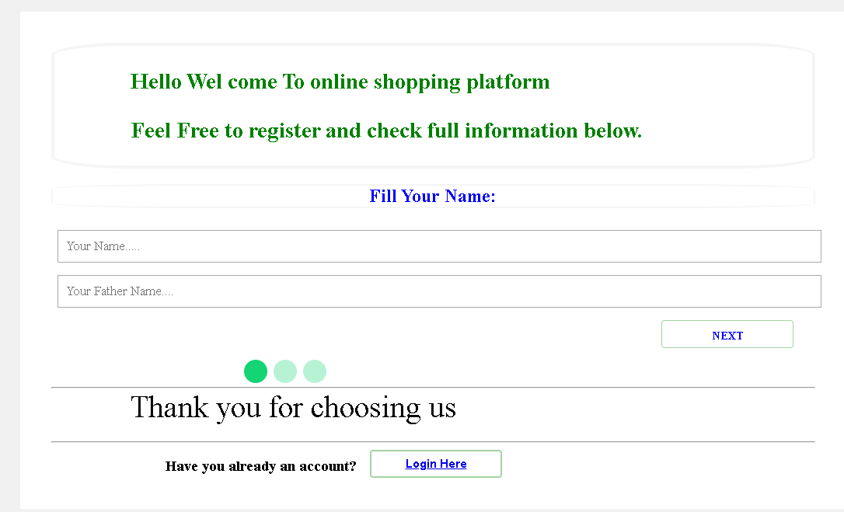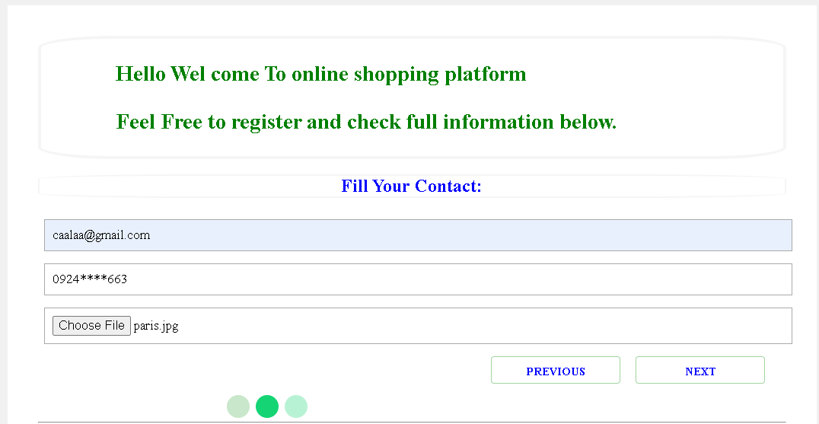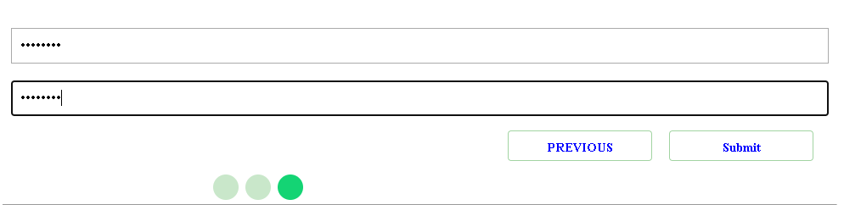

Figure 24. Customer registration page

After customer register they can login to view posted material.

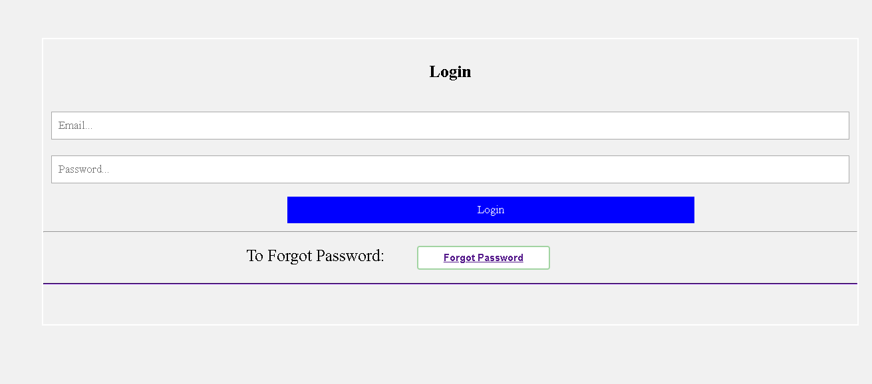

After customer login they can see posted material and give reaction like, comment, like, buy request, comment on service.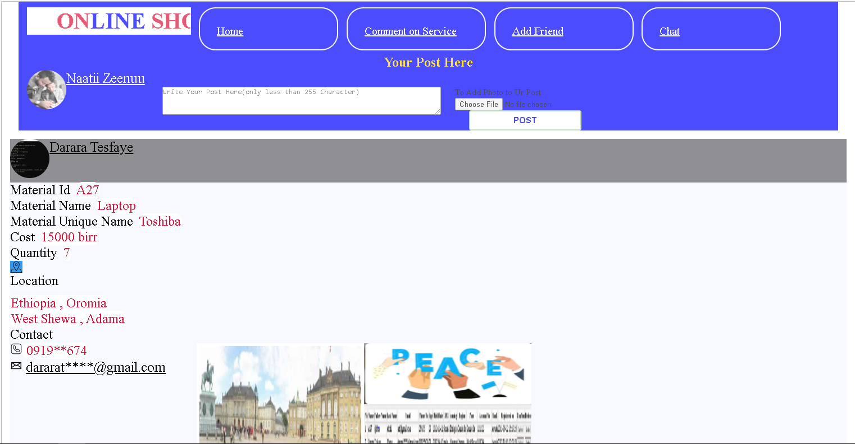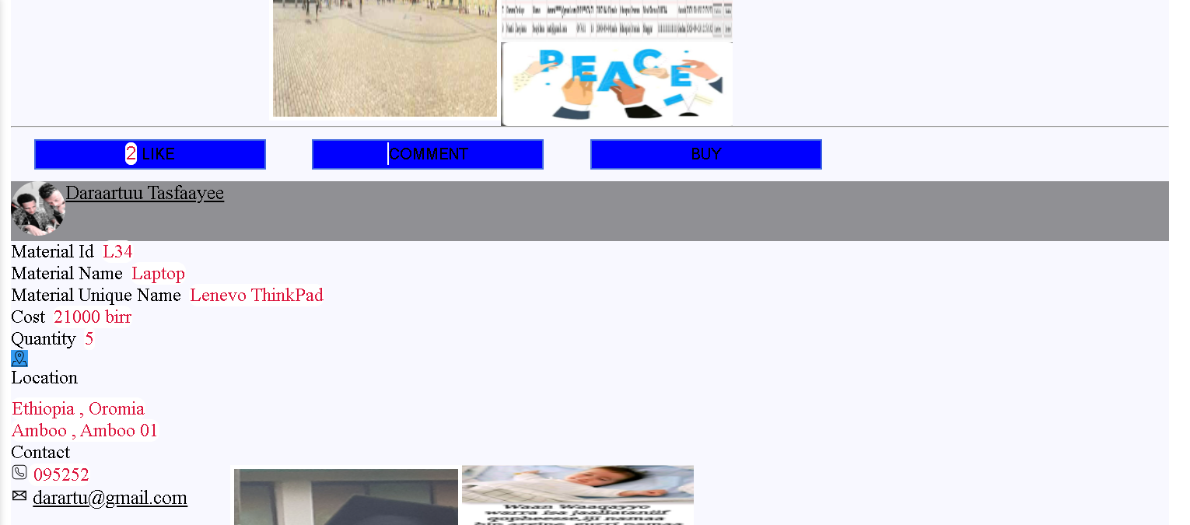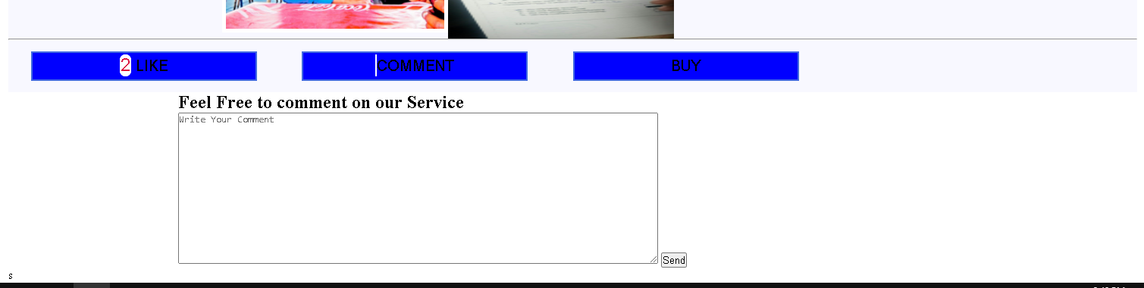

Figure 25. Sample of posted page

## 3.2 Other responsibilities and duties I had during internship

Most of my responsibilities are listed on the above discussion, but in addition to that I have been introduced to some of the technical corrections which needs general and basic computer skills like installing new window on the computers.

## 3.3 Technical knowledge and skills from my course beneficial for my assignment

Through my coursework, I gained a deep understanding of web development concepts including responsive design, cross-browser compatibility, flow control, and what can go wrong in execution of my program. Another is my coursework covered database management concepts, including SQL queries and relational database design. Another thing is problem solving, logical thinking, honed my skills in teamwork, effective communication and project management.

## 3.4 Relevant research projects I had identify in my activities in the organization

I identified several relevant research projects during my activities in the organization. These research projects aimed to address specific challenges or explore opportunities within organization. For example, Game Developing, CCTV Installation and designing and developing mobile app and also they try to create new technology.

# CHAPTER FOUR

REFLECTION AND CONCLUSION

## 4.1 How did internship fit my career goals

This internship fit with my career goals by providing:

* Good inter-personal relationship with co-workers.
* Way to implement the theories I learned to practice.
* Good information used to enhance my creativity.

## 4.2 Did my career goals changed as a result of the internship?

Yes, this internship helped me to focus on what areas I have to work for the future and it also changed my future career goals.

## 4.3 My feelings about the importance of this internship

This internship is very important to increase the capacity of the students to fulfill the works they assigned, and to put what they have learned on the university on the ground.

## 4.4 What challenges i faced during the internship?

The challenges that I faced during the internship includes:

* The problem of workers related with IT related things. Example: Some workers call for help which is already fixed.
* The distance between work place and my home.

## 4.5 Strength and areas of the improvement

### 4.5.1 Strengths

Some of my strengths include:

* Accepting feedback from my supervisor and improving weak point.
* Accepting instructions and doing accordingly.
* Showing interest to do more works and not being reckless.
* Having time for self- reading and trying to create new website.
* Training individually to expand my skill which is related to my field.
* Arriving at work place and stay connected on the online when we have meeting at time.

### 4.5.2 Areas of improvement

* Being late to communicate with co-workers.

# CHAPTER FIVE

RECOMMENDATIONS

## 5.1 Comment with my personal opinion of the company and the internship

## 5.2 Recommendations for improving the internship

### 5.5.1 for the university

* I recommend the university to facilitate good placement opportunities for the students needing the internship.
* I recommend the university to give the students enough amount of money for students to conduct the internship.
* I recommend the university to announce necessary information regarding the internship far before internship period, which will help the students to be ready for the internship.
* I recommend the university to set enough time for students to select the hosting company/organization if it is their responsibility to choice where to conduct the internship.

### 5.5.2 for the hosting organization

* I recommend that the organization to be willing to accommodate the students for conducting internship.
* I recommend the organization to be happy to share the resources as well as the ideas/information to the students/interns.
* I recommend the organization to check the attendance every day and give the students some projects to work on.
* I recommend the organization to check the students how they are working on the projects or given duties.

## 5.3 Should you consider the company for the future student placement?

I think the organization is a good place for students who want to conduct internship activities. I recommend student to go there which have interest on activities related with software development and database related activities. Since company members are graduated from Adama Science and Technology University they know our curriculum and also they have many information which help our (ASTU) students.

# CHAPTER SIX

## REFERENCE

ASTU (2023) , Internship-guideline For Interns 2023

<https://www.backostech.com>

<https://www.w3school.com>

<https://www.google.com>

[t.me/@GPT3_UNLIM_CHATBOT](mailto:t.me/@GPT3_UNLIM_CHATBOT)